

Semester One Examination, 2019

Question/Answer booklet

MATHEMATICS

SOLUTIONS
APPLICATIONS
UNIT 3

Section Two:

Calculator-assumed

Student number: In figures

In words

Your name

Time allowed for this section
Reading time before commencing work: ten minutes
Working time: one hundred minutes

Materials required/recommended for this section
To be provided by the supervisor
This Question/Answer booklet
Formula sheet (retained from Section One)

To be provided by the candidate
Standard items: pens (blue/black preferred), pencils (including coloured), sharpener,
correction fluid/tape, eraser, ruler, highlighters

Special items: drawing instruments, templates, notes on two unfolded sheets of A4 paper, and up to three calculators approved for use in this examination

Important note to candidates
No other items may be taken into the examination room. It is your responsibility to ensure that you do not have any unauthorised material. If you have any unauthorised material with you, hand it to the supervisor before reading any further.

Structure of this paper

Section | Number of questions available | Number of questions to be answered | Working  time (minutes) | Marks available | Percentage of examination
Section One:  Calculator-free | 8 | 8 | 50 | 52 | 35
Section Two:  Calculator-assumed | 13 | 13 | 100 | 98 | 65
 |  |  |  | Total | 100

Instructions to candidates

1. The rules for the conduct of examinations are detailed in the school handbook. Sitting this examination implies that you agree to abide by these rules.

2. Write your answers in this Question/Answer booklet preferably using a blue/black pen.
Do not use erasable or gel pens.

3. You must be careful to confine your answer to the specific question asked and to follow any instructions that are specified to a particular question.

4. Show all your working clearly. Your working should be in sufficient detail to allow your answers to be checked readily and for marks to be awarded for reasoning. Incorrect answers given without supporting reasoning cannot be allocated any marks. For any question or part question worth more than two marks, valid working or justification is required to receive full marks. If you repeat any question, ensure that you cancel the answer you do not wish to have marked.

5. It is recommended that you do not use pencil, except in diagrams.

6. Supplementary pages for planning/continuing your answers to questions are provided at the end of this Question/Answer booklet. If you use these pages to continue an answer, indicate at the original answer where the answer is continued, i.e. give the page number.

7. The Formula sheet is not to be handed in with your Question/Answer booklet.

GENERAL ISSUES IN PAPER
- Rounding – min 3 dp except for money (nearest cent)
- Rounding – using unrounded answers for next part of question
- Working - >2 marks means there must be working
- Working – If it says the ‘explain’ or ‘justify’ then there is marks allocated for that so the answer is not enough (even if it’s only 2 marks)
- Not enough answers – If it’s worth 3 marks then there are 3 things you need to put down

Section Two: Calculator-assumed 65% (98 Marks)
This section has thirteen (13) questions. Answer all questions. Write your answers in the spaces provided.

Working time: 100 minutes.

Question 9 (6 marks)
(a) In a group of five people it was known that Kai was older than Lily, Nat and Jen; Mike was older than Kai and Lily; Nat was older than Jen; and Lily was older than Nat.

(i) Represent this set of age relationships as a digraph. (2 marks)

Solution
See graph
Specific behaviours
✓ all arcs (may complete)
✓ all directions correct (can be old to young or vice versa)
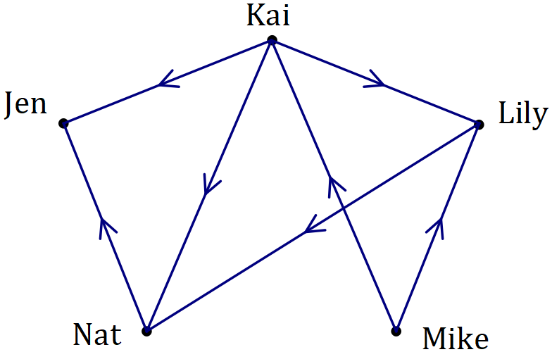

(ii) State the number of arcs in the digraph. (1 mark)
Solution
$7 \text{arcs}$ (10 if complete)
Specific behaviours
correct number

(iii) List the five people in order of age, starting with the youngest. (1 mark)
Solution
Jen, Nat, Lily, Kai, Mike

Specific behaviours
correct order

(b) Graph $H$ is shown below.

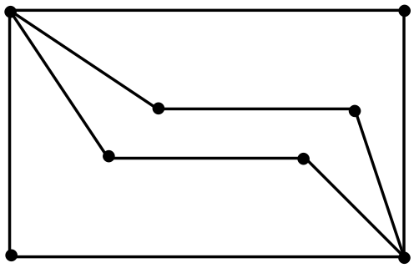

Let $t$ and $p$ be the number of edges in the longest open trail and shortest closed path contained in $H$ respectively. State the values of $t$ and $p$, given that $t>0$ and $p>0$.
(2 marks)
Solution
$$t=9, p=5$$

Specific behaviours
correct value of $t$
correct value of $p$

Question 10 (8 marks)
The following data shows the blood haemoglobin ($H$) levels and packed cell volumes ($V$) of $10$ blood bank donors.

$$H$$ | $$15.5$$ | $$13.6$$ | $$13.8$$ | $$12.9$$ | $$12.5$$ | $$12.3$$ | $$14.8$$ | $$13.1$$ | $$16.1$$ | $$16.4$$
$$V$$ | $$0.45$$ | $$0.42$$ | $$0.44$$ | $$0.42$$ | $$0.41$$ | $$0.39$$ | $$0.43$$ | $$0.41$$ | $$0.45$$ | $$0.47$$

(a) Graph the data on your calculator and describe features of the graph that suggest the presence of a strong and positive linear association between $H$ and $V$. (2 marks)
Solution
Points lie very close to a straight line (strong, linear)
As one variable increases, the other variable also tends to increase (positive)
‘r’ is not a feature of the graph

Specific behaviours
describes one feature
✓ describes all three features (strong, linear, positive)

(b) Determine the equation of the least-squares line that models the relationship between $H$ and $V$, where $H$ is the explanatory variable. (2 marks)
Solution
$$V=0.0147H+0.222$$
Specific behaviours
states correct gradient -1 If not using V & H
✓ states correct intercept

(c) Calculate the correlation coefficient between $H$ and $V$. (1 mark)
Solution
$$r=0.927$$
Specific behaviours
correct value, at least 2dp

(d) What percentage of the variation in $V$ can be explained by the variation in $H$? (1 mark)
Solution
$$86\%$$
Specific behaviours
correct as a percent

(e) Predict the packed cell volume of a donor with a blood haemoglobin level of $13.5$. (1 mark)
Solution
$$\hat{V}(13.5)=0.42$$
Specific behaviours
correct prediction

(f) Describe a potential danger associated with using the least-squares line to predict a packed cell volume from a blood haemoglobin level. (1 mark)
Solution
Any of – extrapolation, Possible 3rd variable, or not enough points in the original data

Specific behaviours
mentions one

Question 11 (7 marks)
A company bought and installed a new computer system with an initial value of $\$29 400$. For accounting purposes, the value of the system decreased by $\$2 450$ each year.

(a) Calculate the value of the system after $3$ years. (1 mark)
Solution
$$29400-3×2450=\$22 050$$

Specific behaviours
correct value

(b) Determine a recurrence relation for $V_{n}$, the value of the system after $n$ years. (2 marks)
Solution
$$V_{n+1}=V_{n}-2450, { V}_{0}=29400$$

Specific behaviours
recurrence relation
✓ shows a correct term of sequence
-1 if doesn’t use V

(c) Determine

(i) the value of the system after $7$ years. (1 mark)
Solution
$$V_{7}=\$12 250$$

Specific behaviours
correct value

(ii) the number of years for the value of the system to become nothing. (1 mark)
Solution
$$V_{n}=0⇒n=12$$

Specific behaviours
correct time

(d) Determine the additional time taken for the system to become worthless if its value decreased by $\$1 470$ each year instead of $\$2 450$. (2 marks)
Solution
$$V_{n+1}=V_{n}-1470, { V}_{0}=29400$$
$$V_{n}=0⇒n=20$$

$$20-12=8 \text{additional years}$$

Specific behaviours
new total time
✓ states additional time

Question 12 (7 marks)
The scatterplot below shows the marks scored by $30$ students in their theory ($t$) and practical ($p$) exams that were marked out of $60$ and $90$ marks respectively.

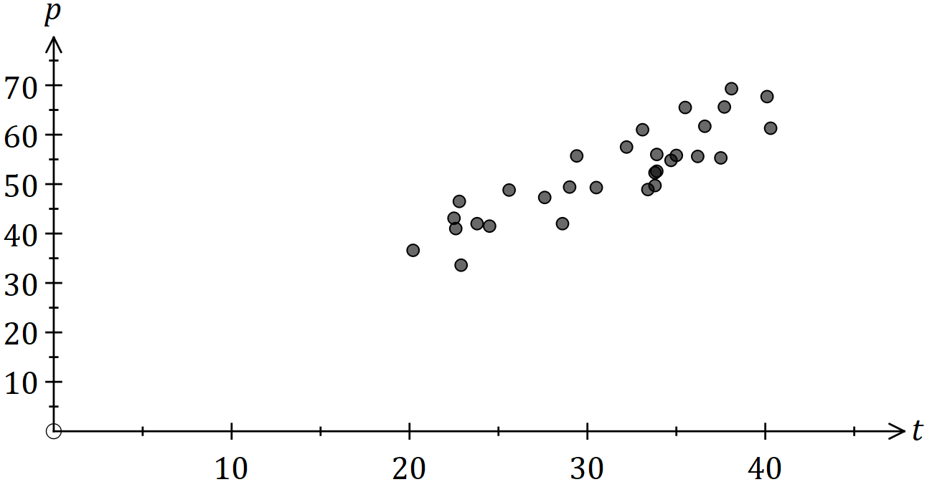

The equation of the least-squares line for the data is $p=1.38t+9.2$.

(a) It was found that $77\%$ of the variation in $p$ could be explained by the variation in $t$. Determine the correlation coefficient $r_{tp}$. (1 mark)
Solution
$$r_{tp}=\sqrt{0.77}=0.877$$

Specific behaviours
correct $r$ to at least 2dp

(b) Interpret the slope of the least-squares line. (2 marks)
Solution
For every extra theory mark the corresponding practical mark tends to increase by $1.38$.

Specific behaviours
identifies increase -1 if not described in actual terms (t & p)
✓ uses $1.38$

(c) Joe and Kai were absent for the practical exam, but it was known that their marks in the theory exam were $28$ and $57$ respectively. Predict their practical exam marks and explain how reliable each prediction is. (4 marks)
Solution
Joe: $p\left(28\right)=48$. Joe's predicted score of 48 is reliable as correlation is strong and it is interpolated.

Kai: $p\left(57\right)=88$. Kai's predicted score of 88 is unreliable as despite strong correlation it is extrapolated.

Specific behaviours
both predictions
✓ comments at least once on strong correlation
✓ uses interpolation to justify Joe's is reliable
✓ uses extrapolation to justify Kai's is unreliable

Question 13 (8 marks)
A builder has quotes from four electricians ($E$) to carry out repairs at four properties ($P$). The quotes are in dollars and not all electricians quoted for all properties, as shown in the table below.
$$(\$)$$ | $$P_{1}$$ | $$P_{2}$$ | $$P_{3}$$ | $$P_{4}$$
$$E_{1}$$ | $$250$$ | $$-$$ | $$480$$ | $$380$$
$$E_{2}$$ | $$-$$ | $$880$$ | $$510$$ | $$-$$
$$E_{3}$$ | $$260$$ | $$-$$ | $$-$$ | $$375$$
$$E_{4}$$ | $$-$$ | $$725$$ | $$-$$ | $$-$$

(a) Draw a weighted bipartite graph to represent this information. (4 marks)
Solution
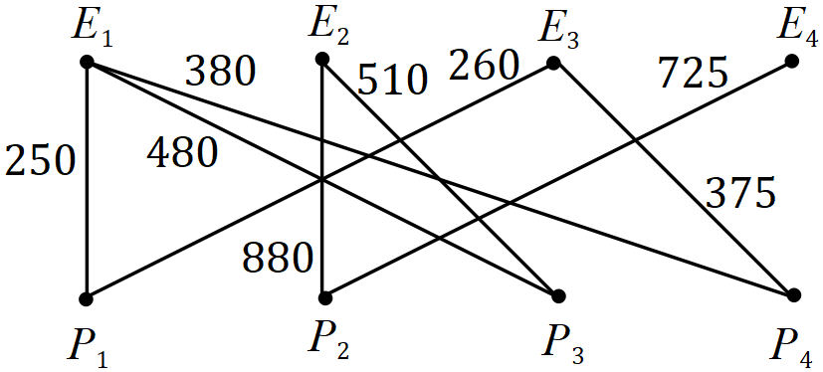

Specific behaviours
row of electricians and row of properties, both labelled
✓ correct number of edges from each $E$ vertex
✓ correct number of edges from each $P$ vertex
✓ adds costs to all edges

The builder decides to give all the electricians one property each to repair.

(b) Calculate the total cost to repair all four properties if $E_{3}$ repaired $P_{1}$. (2 marks)
Solution
$$E_{1}P_{4}+E_{2}P_{3}+E_{3}P_{1}+E_{4}P_{2}$$
$$=380+510+260+725=\$1 875$$

Specific behaviours
indicates correct pairings
✓ correct total

(c) Determine the minimum total repair cost and the allocation of electricians to achieve this minimum. (2 marks)
Solution
$$E_{1}P_{1}+E_{2}P_{3}+E_{3}P_{4}+E_{4}P_{2}$$
$$=250+510+375+725=\$1 860$$

Specific behaviours
states allocation
✓ correct minimum cost

Question 14 (11 marks)
A researcher obtained the following data whilst investigating whether it is possible to reliably predict a child's reading ability ($A$, on a numerical scale of $1$ to $25$) from their hand span ($H$, cm).

Child | B | C | D | E | F | G | J | K | L | M | N | P
$$H$$ | $$11.5$$ | $$12.5$$ | $$16.5$$ | $$15.0$$ | $$14.0$$ | $$13.5$$ | $$12.0$$ | $$13.0$$ | $$17.0$$ | $$15.5$$ | $$14.5$$ | $$12.0$$
$$A$$ | $$10$$ | $$12$$ | $$17$$ | $$15$$ | $$14$$ | $$11$$ | $$11$$ | $$10$$ | $$15$$ | $$14$$ | $$16$$ | $$10$$

(a) State the response variable for this investigation. (1 mark)
Solution
Reading ability

Specific behaviours
correct variable

(b) Add the three missing data points to the scatterplot below. (2 marks)
Solutions (b) and (e)
See scatterplot
Specific behaviours
one point correctly located
✓ all three correctly located

✓ circles all six Year 4's

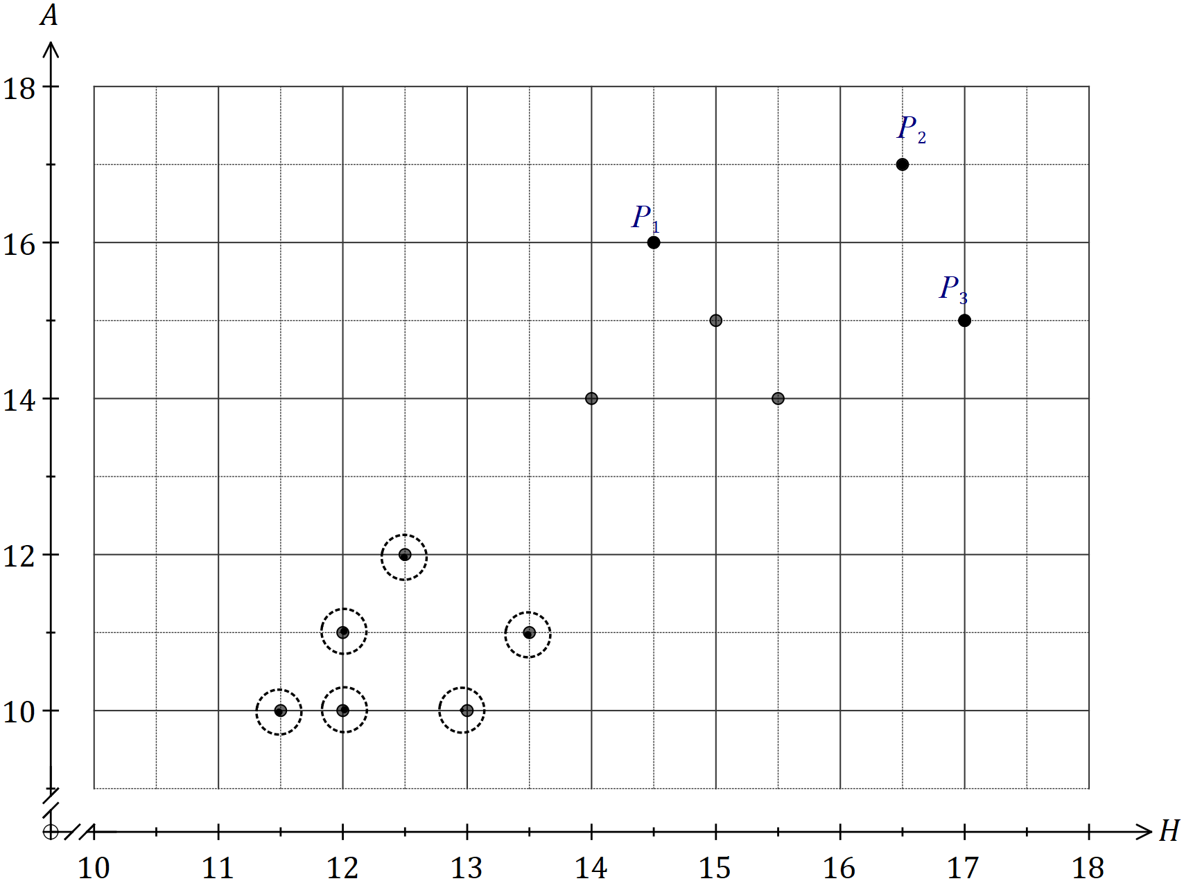

(c) Determine the correlation coefficient between the two variables. (1 mark)
Solution
$$r=0.864$$

Specific behaviours
correct value (at least 2dp)

(d) Using the scatterplot from (b) and the correlation coefficient from (c), the researcher was satisfied that a linear associated existed between $A$ and $H$. Explain why they reached this conclusion. (2 marks)
Solution
The points lie close to a straight line, indicating linear form.

The correlation coefficient is close to 1, indicating a strong association.

Specific behaviours
explains linear form
✓ refers to strong correlation

The researcher then discovered that the children labelled B, C, G, J, K and P were all in Year 4 and the remainder in Year 7.

(e) Circle the Year 4 children on the graph. (1 mark)

(f) Calculate the correlation coefficient between $A$ and $H$ for the Year 4 children only.
(1 mark)
Solution
$$r=0.277$$

Specific behaviours
correct value (at least 2dp)
Follow through only given from (e) if 6 points circled

(g) Identify a non-causal explanation for the conclusion reached by the researcher in (d) and explain how this new information affects that conclusion. (3 marks)
Solution
A non-causal explanation is that the year group of a child is a confounding variable.

The new information indicates there is no association as within a year group the correlation is very weak.

Specific behaviours
✓ identifies year group as a confounding variable
states there is no association
✓ uses weak correlation to justify no association

Question 15 (7 marks)
A water tank is initially empty. At the start of each hour, $120$ L of water is quickly poured into the tank but during the following hour, $15\%$ of all the water in the tank leaks out.

This situation can be modelled by the recurrence relation $V_{n+1}=0.85V_{n}+120, V_{0}=120$, where $V_{n}$ is the volume of water in the tank, in litres, at the start of the $n^{th}$ hour.

(a) Complete the table below, giving volumes to the nearest litre. (2 marks)
Solution
See table
Specific behaviours
at least two correct values
✓ all correct values

$$n$$ | $$0$$ | $$5$$ | $$10$$ | $$15$$ | $$20$$
$$V_{n}$$ | $$120$$ | $$498$$ | $$666$$ | $$741$$ | $$774$$

(b) At the start of which hour does the tank first hold at least $798$ L? (1 mark)
Solution
$$V_{n}≥798⇒n=36$$
At the start of the $36$^{th} hour.

Specific behaviours
correct number

(c) Plot the points from the table on the axes below. (2 marks)

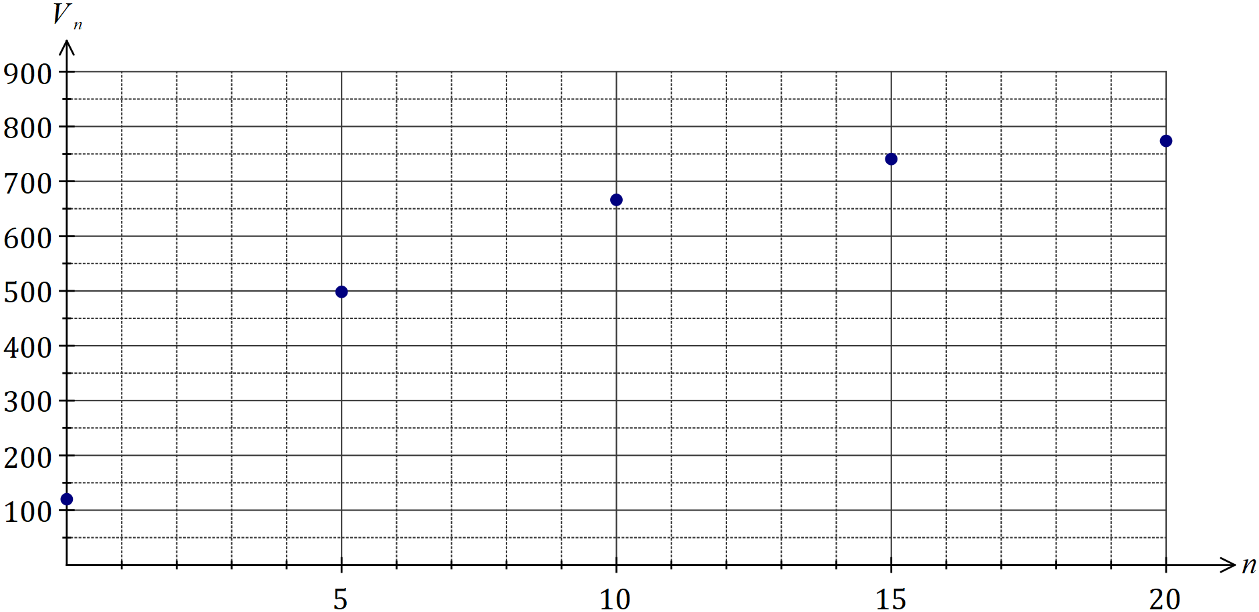
Solution
See graph (plotted points only)
Specific behaviours
at least three correct points
✓ all points correctly plotted

(d) The tank has a maximum capacity of $850$ L. If possible, determine the least number of hours since filling commenced that the tank will start to overflow. If not possible, explain why not. (2 marks)
Solution
Not possible as the amount of water in the tank will never exceed $800$ L.

Specific behaviours
states not possible
✓ uses value of steady-state maximum

Question 16 (9 marks)
A study categorized the weight of hospitalised children as underweight, normal, overweight or obese. The numbers of children in each category are shown by gender in the table below.

 | Underweight | Normal | Overweight | Obese
Female | $$30$$ | $$195$$ | $$52$$ | $$29$$
Male | $$12$$ | $$174$$ | $$81$$ | $$17$$

(a) An obese child is randomly chosen from the study. If possible, explain whether they are more likely to be a boy or a girl. If not possible, explain your reasoning. (2 marks)
Solution
More likely to be a girl, as the number of obese girls is almost twice the number of obese boys.

Specific behaviours
chooses girls
✓ explanation that compares numbers

(b) What percentage of the boys in the study were classified as underweight? (2 marks)
Solution (b)
$$\frac{12}{284}=4.2\%$$

Specific behaviours
correct fraction
✓ correct percentage

Solution (c)
See table
Specific behaviours
two entries correct
✓ one row correct
✓ all entries correct

(c) Complete the table of row percentages below to the nearest whole number. (3 marks)

(%) | Underweight | Normal | Overweight | Obese
Female | $$10$$ | $$64$$ | $$17$$ | $$9$$
Male | $$4$$ | $$61$$ | $$29$$ | $$6$$

(d) Does the table of row percentages suggest the presence of an association between the categorical variables? Justify your answer. (2 marks)
Solution
Yes, as the percentages in each column are quite different. For example, 10% of girls are underweight but only 4% of boys are.

Specific behaviours
yes to association
✓ uses differences in column percentages to justify

Question 17 (6 marks)
A piledriver is hammering a pile into the ground. The graph below shows the distance $T_{n}$ (in cm) the pile moves into the ground on the $n^{th}$ hit of the piledriver.

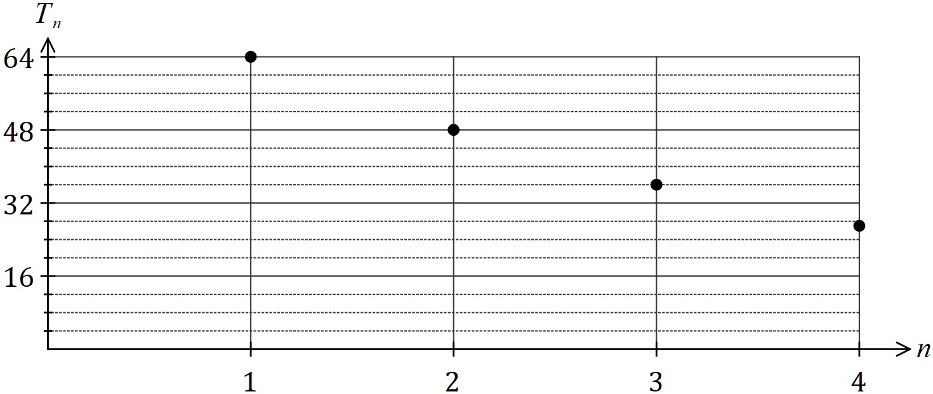

The values of $T_{n}$ form a geometric sequence.

(a) Use information from the graph to determine the common ratio for the sequence. (1 mark)
Solution
$$r=48÷64=0.75$$

Specific behaviours
correct ratio

(b) Write a recurrence relation to generate the values of $T_{n}$. (2 marks)
Solution
$$T_{n+1}=T_{n}×0.75, T_{1}=64$$

Specific behaviours
recurrence relation
✓ states value of $T_{1}$

(c) Write the $n^{th}$ term rule for the values of $T_{n}$. (1 mark)
Solution
$$T_{n}={64\left(0.75\right)}^{n-1}$$

Specific behaviours
correct rule

(d) Determine

(i) the distance the pile moves into the ground on the tenth hit of the piledriver.
(1 mark)
Solution
$$T_{10}=4.8 \text{cm}$$

Specific behaviours
correct distance

(ii) on which hit the pile first moves less than one mm into the ground. (1 mark)
Solution
$$T_{n}<0.1⇒n=24$$

Specific behaviours
correct value

Question 18 (7 marks)
Each vertex on the graph below represents an airport and an edge between two airports indicates that an airline has a direct flight, in both directions, between the airports.

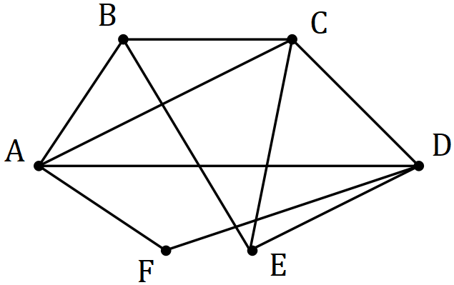

(a) Redraw the graph to clearly show that it is planar. (1 mark)
Solution
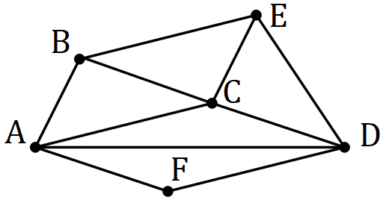
Specific behaviours
correct equivalent, no crossed edges

(b) Demonstrate that the graph satisfies Euler's formula. (2 marks)
Solution
$$v+f-e=6+6-10=2$$

Specific behaviours
correct count of $v, f$ and $e$
✓ substitutes into formula and simplifies correctly

In order to check in-flight catering quality, an airline manager plans to leave airport $A$, travel on at least one flight between the $10$ pairs of airports and then return to $A$. The manager does not use any other mode of transport between airports.

(c) Determine the minimum number of flights the manager must take and list, in order, the airports visited. (2 marks)
Solution
$$A-F-D-A-C-D-E-C-B-E-B-A=11 \text{flights}$$

Specific behaviours
correct number
✓ correct list (many exist) – There are other possible lists

(d) Another manager, based at a different airport, claimed they could carry out the quality check in fewer flights by starting and finishing at their airport. Comment on this claim.
(2 marks)
Solution
Claim is FALSE. Graph is semi-Eulerian so as there are 10 edges there must be a double up somewhere.

Specific behaviours
✓ disagrees with claim conditionally
states the graph is semi Eulerian

Question 19 (6 marks)
A statistician wants to check whether a linear model is appropriate for a bivariate data set they are analysing. The least-squares line to model the linear relationship is $y=2.09x+8.88$ and the correlation coefficient between the variables is very strong.

The residual plot using the linear model is shown below for all but two of the data points.

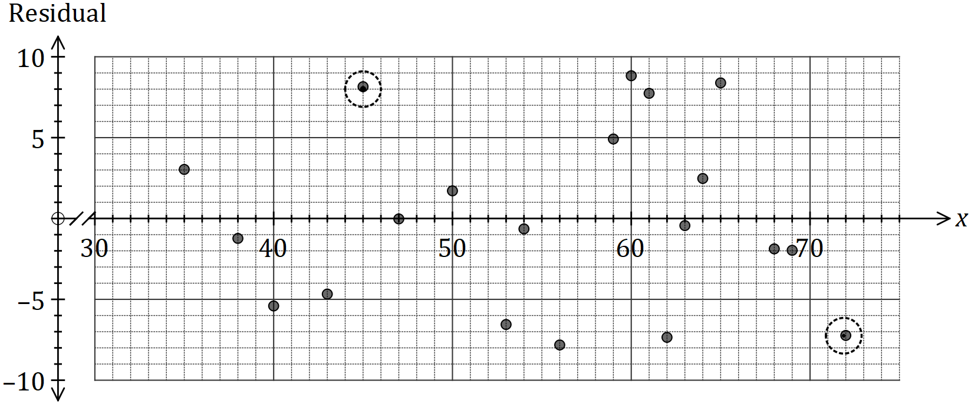

(a) Calculate the residuals for the missing points $(45, 111)$ and $(72, 152)$ and plot them on the graph above. (4 marks)
Solution
$$y\left(45\right)=102.93 \text{and} 111-102.93=8.07$$

$$y\left(72\right)=159.36 \text{and} 152-159.36=-7.36$$

Specific behaviours
calculates both predicted values
✓ residual for one point
✓ residual for second point
✓ accurately plots both residuals

(b) Use the residual plot to explain whether fitting a linear model to the data is appropriate.
(2 marks)
Solution
Linear model is appropriate as no pattern is evident in the residuals.

Specific behaviours
states linear model is appropriate
✓ refers to no pattern evident in residuals

Question 20 (8 marks)
The vertices below represent $8$ computers in a network and the weights on each edge represent the time, in milliseconds, for a signal to be sent directly between connected computers.

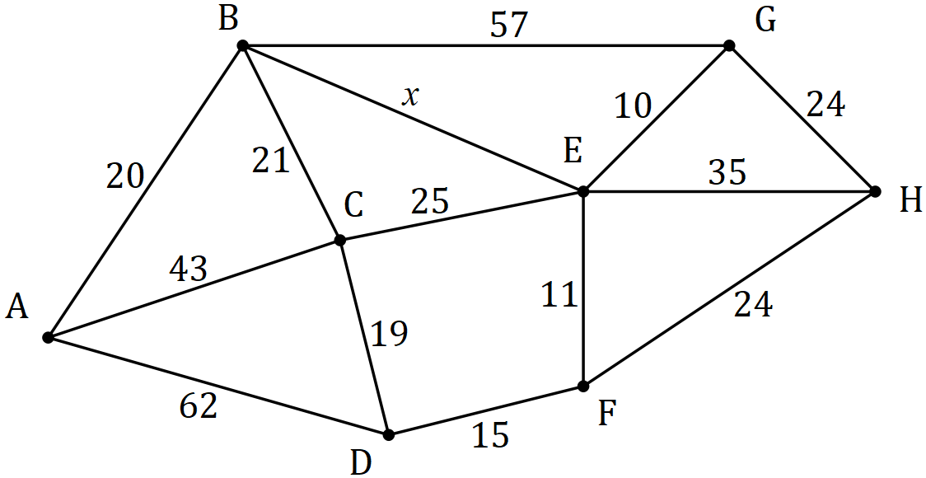

(a) Given that $x=48$, determine the path required and the time taken to send a signal in the least time between

(i) $B$ and $G$. (2 marks)
Solution
$$B-C-E-G \text{in} 21+25+10=56 \text{ms}$$

Specific behaviours
correct path; ✓ correct time for stated path

(ii) $A$ and $E$. (2 marks)
Solution
$$A-B-C-E{\text{in}} 20+21+25=66 \text{ms}$$

Specific behaviours
correct path; ✓ correct time for stated path

(iii) $A$ and $H$. (2 marks)
Solution
$$A-B-C-D-F-H \text{in} 20+21+19+15+24=99 \text{ms}$$

Specific behaviours
correct path; ✓ correct time for stated path

(b) Determine the largest value of $x$, to the nearest millisecond, to ensure that the fastest route to send a signal between $A$ and $H$ will pass through $E$. Justify your answer.
Solution
$$A-B-E-G-H \text{in} 20+x+10+24=54+x$$

$$54+x<99 \text{and so largest value of} x=44$$

Specific behaviours
explanation
✓ correct value of $x$

(2 marks)

Question 21 (8 marks)
(a) An investor has $\$540$ in an account. One month later, and at the start of each subsequent month, a deposit of $\$35$ is added to the account. Interest, calculated as $0.72\%$ of the balance at the start of the month, is added to the account just before each deposit is made.

The account balance after $n$ deposits is $T_{n}$, and can be modelled by the recurrence relation $T_{n+1}=1.0072T_{n}+35, T_{0}=540$.

(i) Determine the balance in the account after $4$ deposits have been made. (1 mark)
Solution
$$T_{4}=\$697.24$$

Specific behaviours
correct amount

(ii) After how many deposits does the balance of the account first exceed $\$1 200$ and what is the balance of the account at that time. (2 marks)
Solution
$$T_{n}>1200⇒n=17$$

$$T_{17}=\$1 240.58$$

Specific behaviours
correct month; ✓ correct amount Must be 2dp for Money – click on cell

(b) The investor also has $\$85$ in another account. One week later, and at the start of each subsequent week, a deposit of $\$5.75$ is added to the account. Interest, calculated as $0.095\%$ of the balance at the start of the week, is added to the account just before each deposit is made.

(i) Write a recurrence relation to model the balance of this account after $n$ deposits.
(3 marks)
Solution
$$T_{n+1}=1.00095T_{n}+5.75, T_{0}=85$$

Specific behaviours
correct multiplier; ✓ correct addition; ✓ correct initial term (must be T₀)

(ii) Determine the balance in this account after $40$ deposits have been made. (1 mark)
Solution
$$T_{40}=\$322.60$$

Specific behaviours
correct amount

(iii) By considering the total deposits made, or otherwise, determine the total interest added to this account after $40$ deposits have been made. (1 mark)
Solution
$$\text{Deposits}=40×5.75=230$$
$$\text{Interest}=322.60-85-230=\$7.60$$

Specific behaviours
correct amount

Supplementary page

Question number: _________

Supplementary page

Question number: _________

Supplementary page

Question number: _________

© 2019 WA Exam Papers. Kennedy Baptist College has a non-exclusive licence to copy and communicate this document for non-commercial, educational use within the school. No other copying, communication or use is permitted without the express written permission of WA Exam Papers. SN245-136-4.

